EEE 591 : Python for Rapid Engineering Solutions
Project 1 Report
Sakshi Vijay Lathi - 1234549838
AI Citation : https://gemini.google.com/share/99dc673e0103

PROBLEM 1: DATA ANALYSIS
1.1 Dataset Overview
The heart disease dataset (heart1.csv) contains 270 patient records with 13 medical features and 1 target variable (a1p2). The target variable indicates absence (1) or presence (2) of heart disease. The dataset contains no missing values across any of the 14 columns, making it clean and ready for analysis without imputation.
Property | Value
File | heart1.csv
Total Records | 270
Total Features | 13 (all used, none dropped, no PCA)
Target Variable | a1p2 (1 = No Heart Disease, 2 = Heart Disease)
Missing Values | 0
1.2 Dataset Variables
Num | Name | Description
0 | age | Patient age
1 | sex | Sex (1=male, 0=female)
2 | cpt | Chest pain type (4 values)
3 | rbp | Resting blood pressure
4 | sc | Serum cholesterol in mg/dl
5 | fbs | Fasting blood sugar > 120 mg/dl
6 | rer | Resting electrocardiographic results (0,1,2)
7 | mhr | Maximum heart rate achieved
8 | eia | Exercise induced angina
9 | opst | ST depression induced by exercise relative to rest
10 | dests | Slope of the peak exercise ST segment
11 | nmvcf | Number of major vessels (0-3) colored by fluoroscopy
12 | thal | Thallium stress test (3=normal, 6=fixed, 7=reversible)
13 | a1p2 | TARGET: 1=no heart disease, 2=heart disease

1.3 Descriptive Statistics
Stat | age | sex | cpt | rbp | sc | fbs | rer | mhr | eia | opst | dests | nmvcf | thal
count | 270 | 270 | 270 | 270 | 270 | 270 | 270 | 270 | 270 | 270 | 270 | 270 | 270
mean | 54.43 | 0.68 | 3.17 | 131.34 | 249.66 | 0.15 | 1.02 | 149.68 | 0.33 | 1.05 | 1.59 | 0.67 | 4.70
std | 9.11 | 0.47 | 0.95 | 17.86 | 51.69 | 0.36 | 1.00 | 23.17 | 0.47 | 1.15 | 0.61 | 0.94 | 1.94
min | 29.00 | 0.00 | 1.00 | 94.00 | 126.00 | 0.00 | 0.00 | 71.00 | 0.00 | 0.00 | 1.00 | 0.00 | 3.00
25% | 48.00 | 0.00 | 3.00 | 120.00 | 213.00 | 0.00 | 0.00 | 133.00 | 0.00 | 0.00 | 1.00 | 0.00 | 3.00
50% | 55.00 | 1.00 | 3.00 | 130.00 | 245.00 | 0.00 | 2.00 | 153.50 | 0.00 | 0.80 | 2.00 | 0.00 | 3.00
75% | 61.00 | 1.00 | 4.00 | 140.00 | 280.00 | 0.00 | 2.00 | 166.00 | 1.00 | 1.60 | 2.00 | 1.00 | 7.00
max | 77.00 | 1.00 | 4.00 | 200.00 | 564.00 | 1.00 | 2.00 | 202.00 | 1.00 | 6.20 | 3.00 | 3.00 | 7.00
1.4 Correlation of Each Feature with Target (a1p2)
Sorted by absolute correlation value descending. Statistical significance tested using point-biserial correlation with alpha = 0.05.
Feature | Pearson r | |r| | p-value | Significant?
thal | +0.5250 | 0.5250 | 1.57e-20 | Yes (p<0.05)
nmvcf | +0.4553 | 0.4553 | 3.17e-15 | Yes (p<0.05)
eia | +0.4193 | 0.4193 | 6.38e-13 | Yes (p<0.05)
mhr | -0.4185 | 0.4185 | 7.12e-13 | Yes (p<0.05)
opst | +0.4180 | 0.4180 | 7.68e-13 | Yes (p<0.05)
cpt | +0.4174 | 0.4174 | 8.26e-13 | Yes (p<0.05)
dests | +0.3376 | 0.3376 | 1.27e-08 | Yes (p<0.05)
sex | +0.2977 | 0.2977 | 6.27e-07 | Yes (p<0.05)
age | +0.2123 | 0.2123 | 4.43e-04 | Yes (p<0.05)
rer | +0.1821 | 0.1821 | 2.67e-03 | Yes (p<0.05)
rbp | +0.1554 | 0.1554 | 1.06e-02 | Yes (p<0.05)
sc | +0.1180 | 0.1180 | 5.27e-02 | No
fbs | -0.0163 | 0.0163 | 7.90e-01 | No

1.5 Full Correlation Matrix - Heatmap
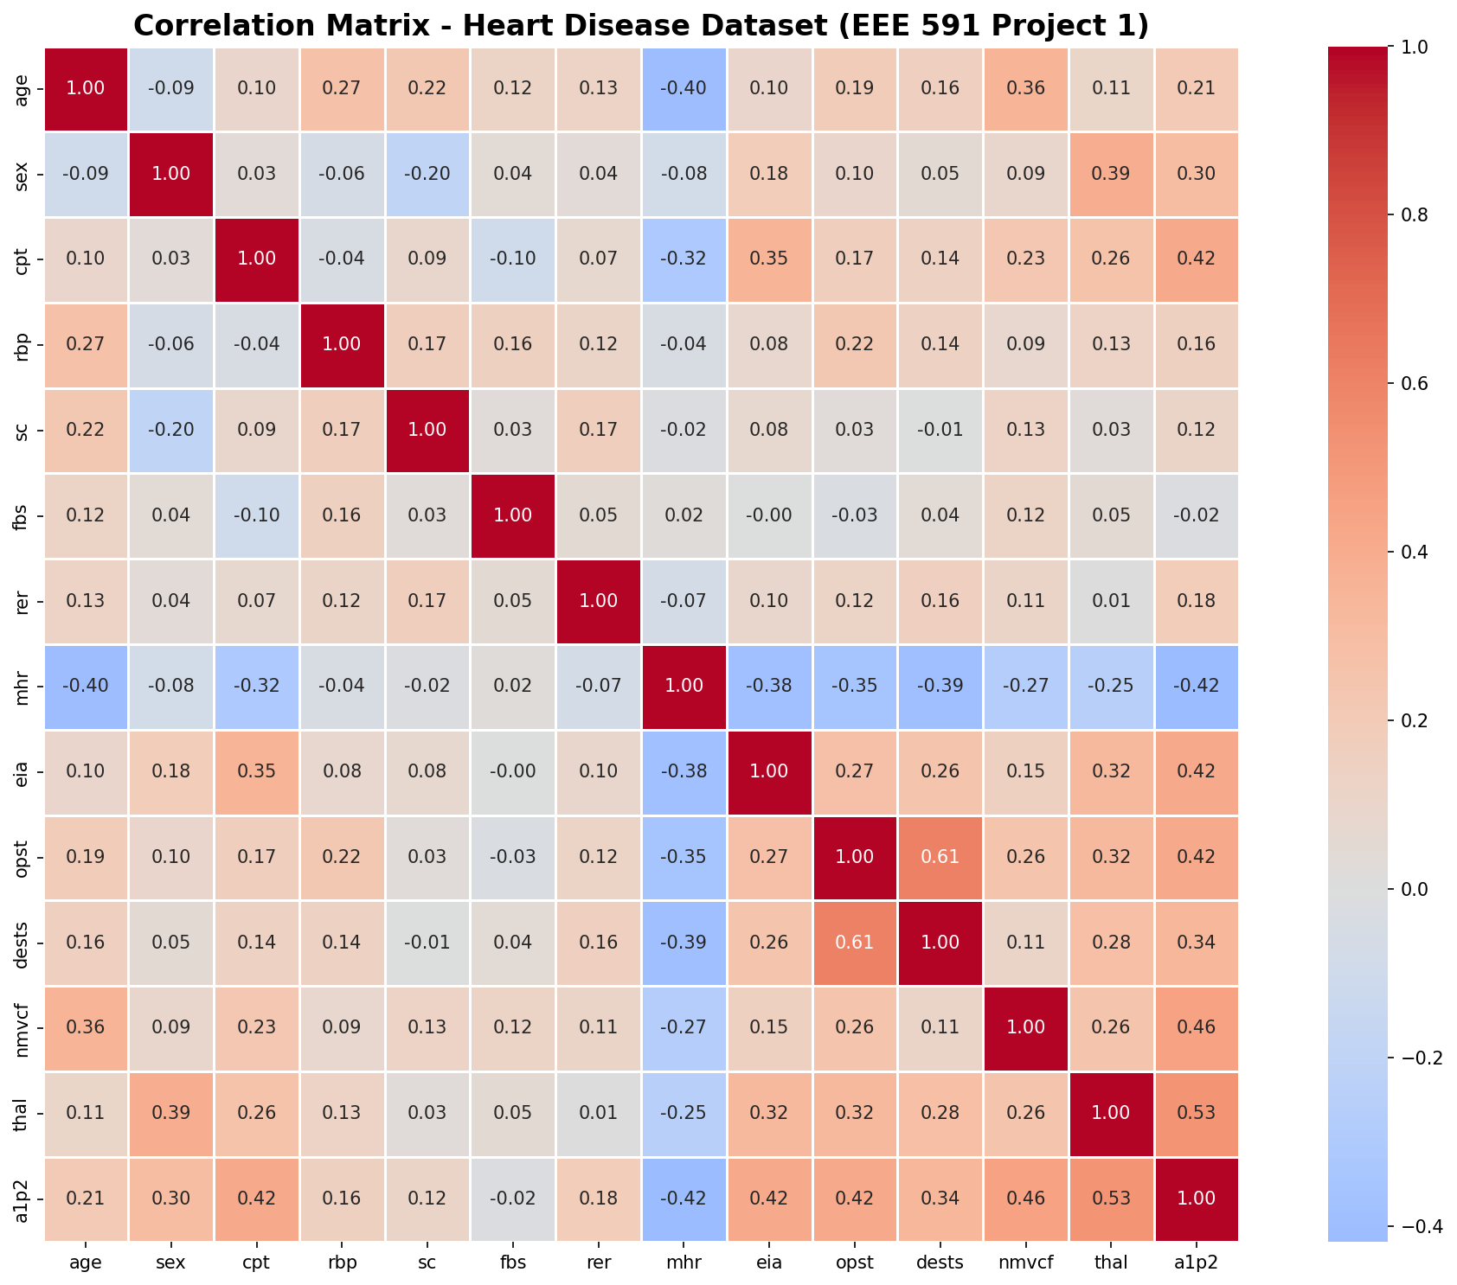
1.6 Top 5 Feature Pairs Most Correlated With Each Other
Excluding self-correlation and target variable (a1p2).
Rank | Feature 1 | Feature 2 | Correlation (r)
1 | opst | dests | +0.6097
2 | age | mhr | -0.4022
3 | sex | thal | +0.3910
4 | mhr | dests | -0.3868
5 | mhr | eia | -0.3807
1.7 Top 5 Features Most Correlated with Target (a1p2)
Rank | Feature | Correlation | Interpretation
1 | thal | +0.5250 | Strong positive predictor
2 | nmvcf | +0.4553 | Strong positive predictor
3 | eia | +0.4193 | Moderate positive predictor
4 | mhr | -0.4185 | Moderate negative predictor
5 | opst | +0.4180 | Moderate positive predictor
1.8 Class Balance Analysis
Class | Count | Percentage | Status
Class 1 – No Heart Disease | 150 | 55.6% | Majority
Class 2 – Heart Disease | 120 | 44.4% | Minority
Dataset Status | BALANCED | Minority >= 40% | No resampling needed
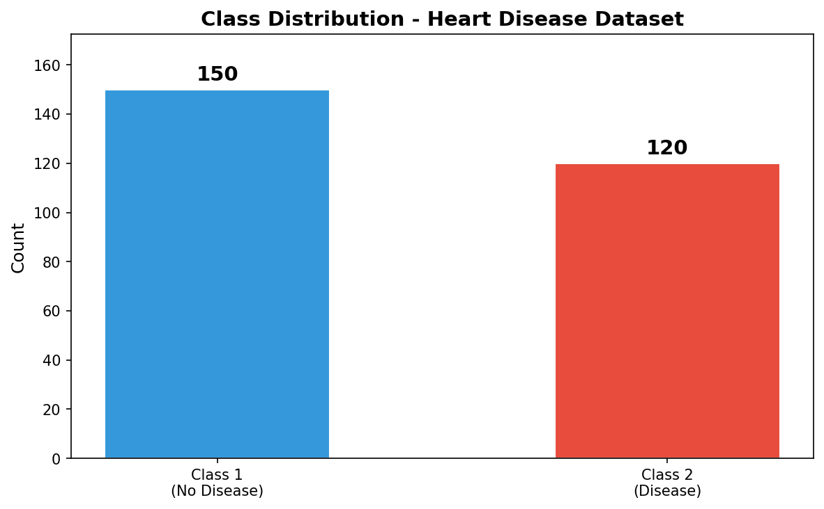
1.9 Distribution Analysis – Skewness and Kurtosis
Feature | Skewness | Kurtosis | Distribution
age | -0.1636 | -0.5448 | Approx. Normal
sex | -0.7651 | -1.4253 | Left-Skewed
cpt | -0.8788 | -0.2965 | Left-Skewed
rbp | 0.7226 | 0.9231 | Right-Skewed
sc | 1.1837 | 4.8956 | Right-Skewed
fbs | 1.9920 | 1.9826 | Right-Skewed
rer | -0.0447 | -2.0054 | Approx. Normal
mhr | -0.5277 | -0.1031 | Left-Skewed
eia | 0.7289 | -1.4797 | Right-Skewed
opst | 1.2629 | 1.7593 | Right-Skewed
dests | 0.5432 | -0.6066 | Right-Skewed
nmvcf | 1.2099 | 0.2982 | Right-Skewed
thal | 0.2873 | -1.9006 | Approx. Normal

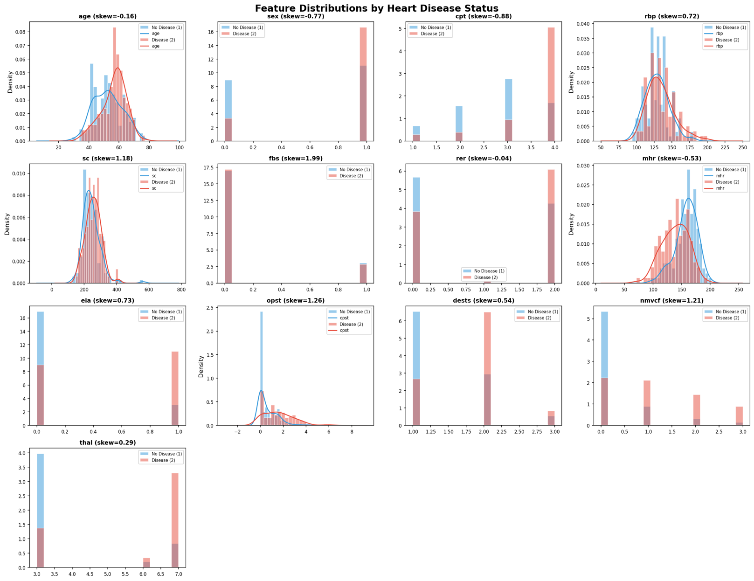
1.10 Feature Importance – Point-Biserial Correlation
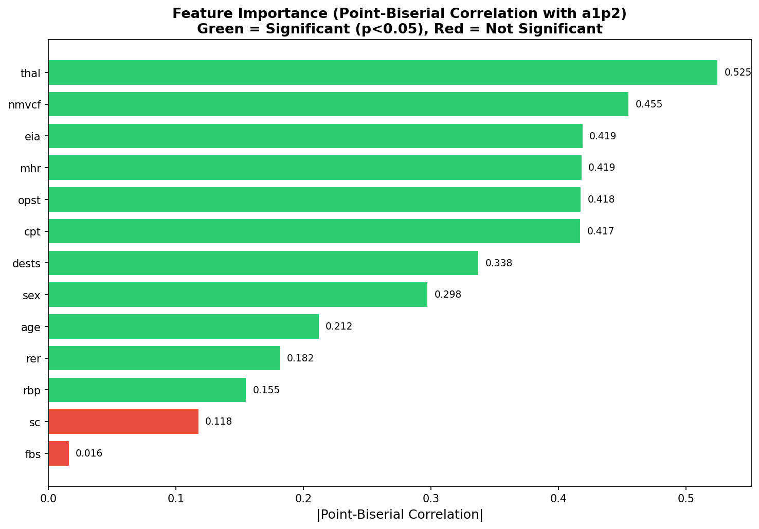
1.11 Outlier Detection (IQR Method)
Feature | # Outliers | % Outliers
age | 0 | 0.0%
sex | 0 | 0.0%
cpt | 20 | 7.4%
rbp | 9 | 3.3%
sc | 5 | 1.9%
fbs | 40 | 14.8%
rer | 0 | 0.0%
mhr | 1 | 0.4%
eia | 0 | 0.0%
opst | 4 | 1.5%
dests | 0 | 0.0%
nmvcf | 19 | 7.0%
thal | 0 | 0.0%
Features with outliers: 7 out of 13
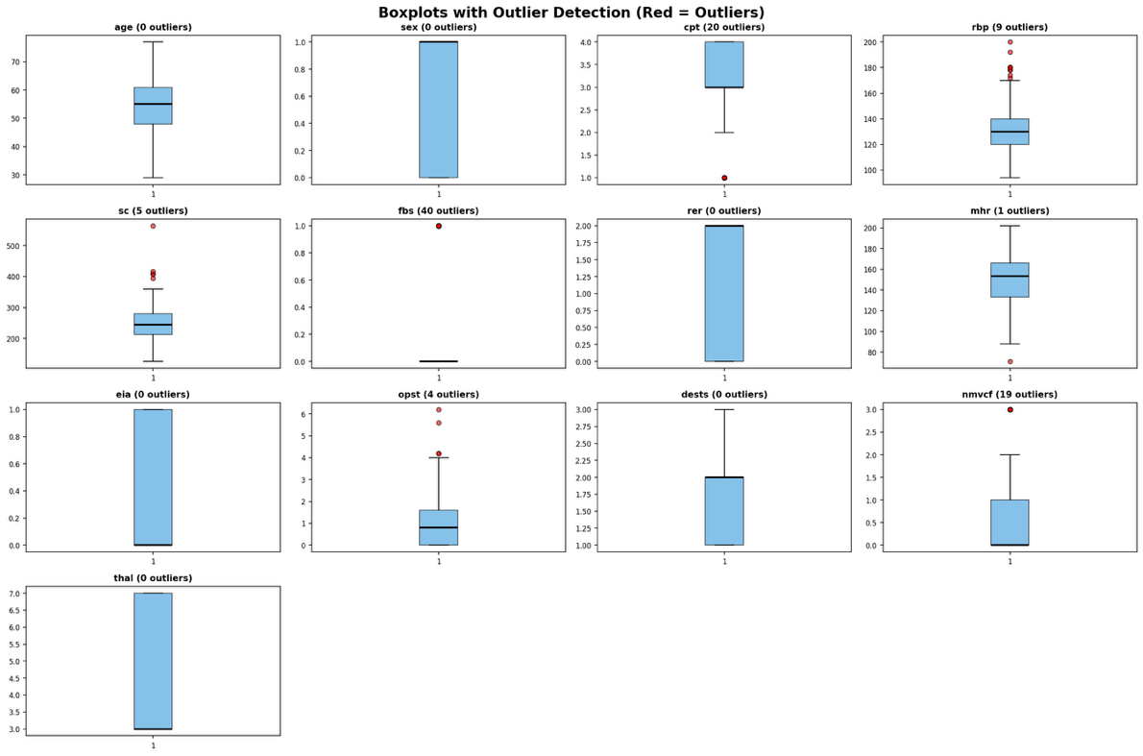

1.12 Pair Plot
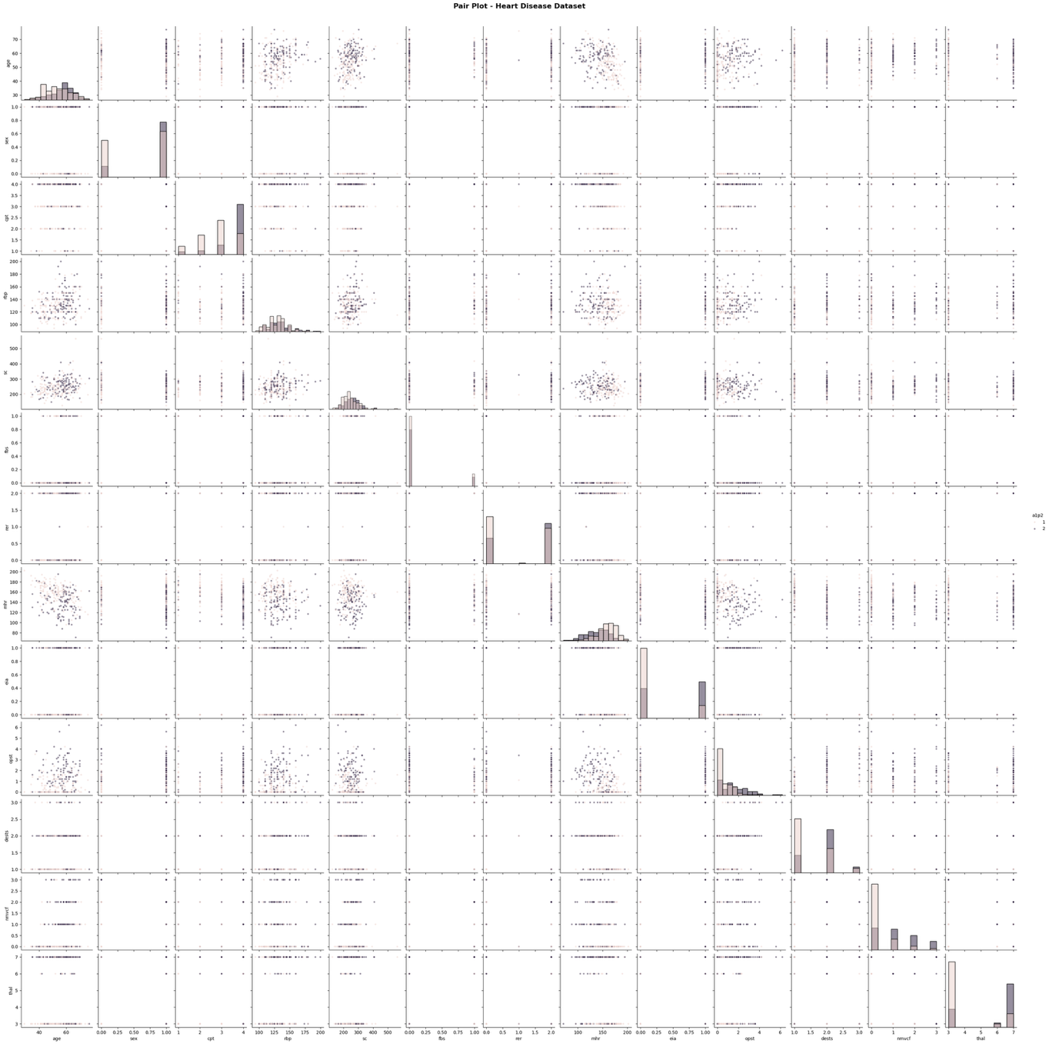

1.13 Management Summary - Problem 1
After analyzing the heart disease dataset with 270 patient records and 13 features, here is what I found. The features most strongly linked to heart disease were thal (r = 0.525), nmvcf (r = 0.455), eia (r = 0.419), mhr (r = -0.419), and opst (r = 0.418). Thal being the strongest predictor makes sense since it directly measures heart function through the thallium stress test. I also noticed that opst and dests are highly correlated with each other (r = 0.610), and age and mhr are negatively correlated (r = -0.402), meaning older patients tend to have lower maximum heart rates. The dataset is fairly balanced with 150 patients without heart disease and 120 with it, so we should not need any special balancing techniques. Out of 13 features, 11 turned out to be statistically significant predictors based on p-value testing. Only sc and fbs were not significant, though I kept all features as required. Based on these findings I think machine learning models should be able to predict heart disease pretty well, probably in the range of 0.80 to 0.94 accuracy, with methods like SVM and Random Forest likely doing the best.

PROBLEM 2: MACHINE LEARNING CLASSIFIERS
Problem 2: Machine Learning Classifiers
2.1 Methodology
The heart disease dataset was split into training (80%) and test (20%) sets using train_test_split with random_state=42, yielding 216 training samples and 54 test samples. All 13 features were retained without elimination or dimensionality reduction (no PCA used). Features were standardized using StandardScaler fitted on training data only and applied to both training and test sets to prevent data leakage. Six supervised learning classifiers were trained and evaluated. Combined Accuracy refers to accuracy computed on the full dataset (all 270 samples) using the trained model.
2.2 Classifier Parameters
Classifier | Parameters Used
Perceptron | max_iter=1000, random_state=42, tol=1e-3
Logistic Regression | max_iter=1000, random_state=42, solver=lbfgs
Support Vector Machines | kernel=rbf, C=1.0, gamma=scale, random_state=42
Decision Tree | max_depth=5, random_state=42
Random Forest | n_estimators=100, max_depth=5, random_state=42
K-Nearest Neighbor | n_neighbors=11, metric=euclidean
2.3 Classifier Results
These are all the results I got:
Perceptron Results:
Accuracy: 0.85
Combined Accuracy: 0.84
Logistic Regression Results:
Accuracy: 0.91
Combined Accuracy: 0.86
Support Vector Machines Results:
Accuracy: 0.94
Combined Accuracy: 0.92
Decision Tree Results:
Accuracy: 0.78
Combined Accuracy: 0.90
Random Forest Results:
Accuracy: 0.93
Combined Accuracy: 0.94
K-Nearest Neighbor Results:
Accuracy: 0.91
Combined Accuracy: 0.84

2.4 Comparison Table
Best Method: Support Vector Machines (Test Accuracy: 0.94)
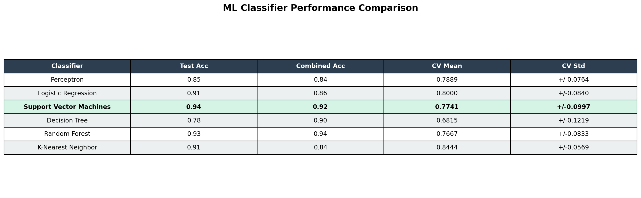
2.5 Confusion Matrices
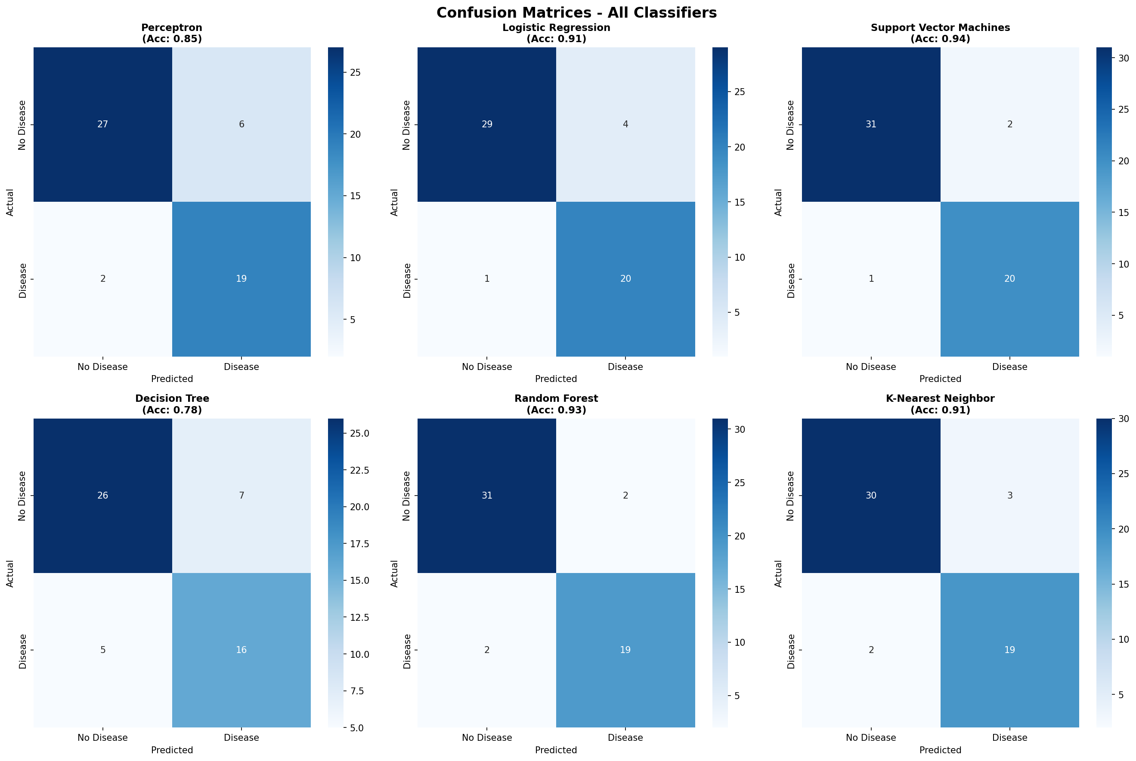
Classifier | TN (No Disease) | FP | FN | TP (Disease) | Accuracy | Precision (Disease) | Recall (Disease) | F1 (Disease)
Perceptron | 27 | 6 | 2 | 19 | 0.85 | 0.76 | 0.90 | 0.83
Logistic Regression | 29 | 4 | 1 | 20 | 0.91 | 0.83 | 0.95 | 0.89
Support Vector Machines | 31 | 2 | 1 | 20 | 0.94 | 0.91 | 0.95 | 0.93
Decision Tree | 26 | 7 | 5 | 16 | 0.78 | 0.70 | 0.76 | 0.73
Random Forest | 31 | 2 | 2 | 19 | 0.93 | 0.90 | 0.90 | 0.90
K-Nearest Neighbor | 30 | 3 | 2 | 19 | 0.91 | 0.86 | 0.90 | 0.88
2.6 KNN K-Selection via Cross-Validation
K values from 1 to 30 were evaluated using 5-fold cross-validation. Optimal K = 11 with CV accuracy of 0.8444.
K | CV Accuracy | K | CV Accuracy | K | CV Accuracy
1 | 0.7593 | 11 | 0.8444 ← BEST | 21 | 0.8222
2 | 0.7370 | 12 | 0.8259 | 22 | 0.8222
3 | 0.7704 | 13 | 0.8259 | 23 | 0.8111
4 | 0.7815 | 14 | 0.8185 | 24 | 0.8148
5 | 0.8037 | 15 | 0.8222 | 25 | 0.8111
6 | 0.7926 | 16 | 0.8222 | 26 | 0.8074
7 | 0.8037 | 17 | 0.8111 | 27 | 0.8185
8 | 0.8111 | 18 | 0.8222 | 28 | 0.8074
9 | 0.8111 | 19 | 0.8222 | 29 | 0.8259
10 | 0.8259 | 20 | 0.8222 | 30 | 0.8185
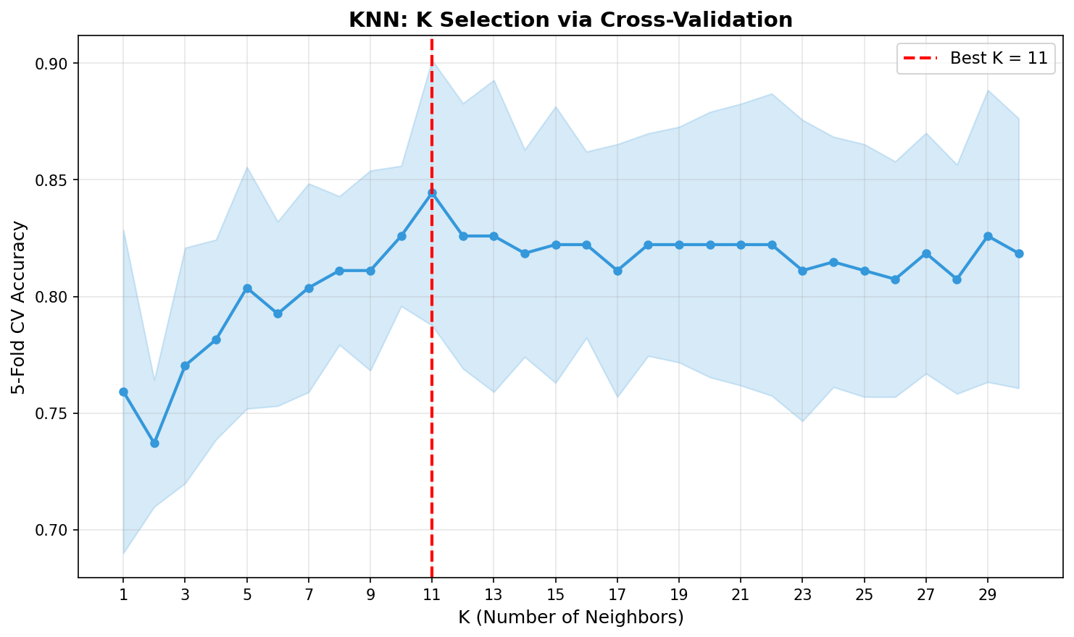
2.7 Cross-Validation Analysis (5-Fold CV)
Classifier | CV Mean Accuracy | CV Std Dev
Perceptron | 0.7889 | +/- 0.0764
Logistic Regression | 0.8000 | +/- 0.0840
Support Vector Machines | 0.7741 | +/- 0.0997
Decision Tree | 0.6815 | +/- 0.1219
Random Forest | 0.7667 | +/- 0.0833
K-Nearest Neighbor | 0.8444 | +/- 0.0569
Best by CV: K-Nearest Neighbor (Mean: 0.8444, Std: 0.0569)
CV scores are lower than single-split test scores because cross-validation provides a more conservative and realistic estimate of generalization performance. The lower standard deviation for KNN (0.0569) also indicates it is the most consistent performer across different data splits.
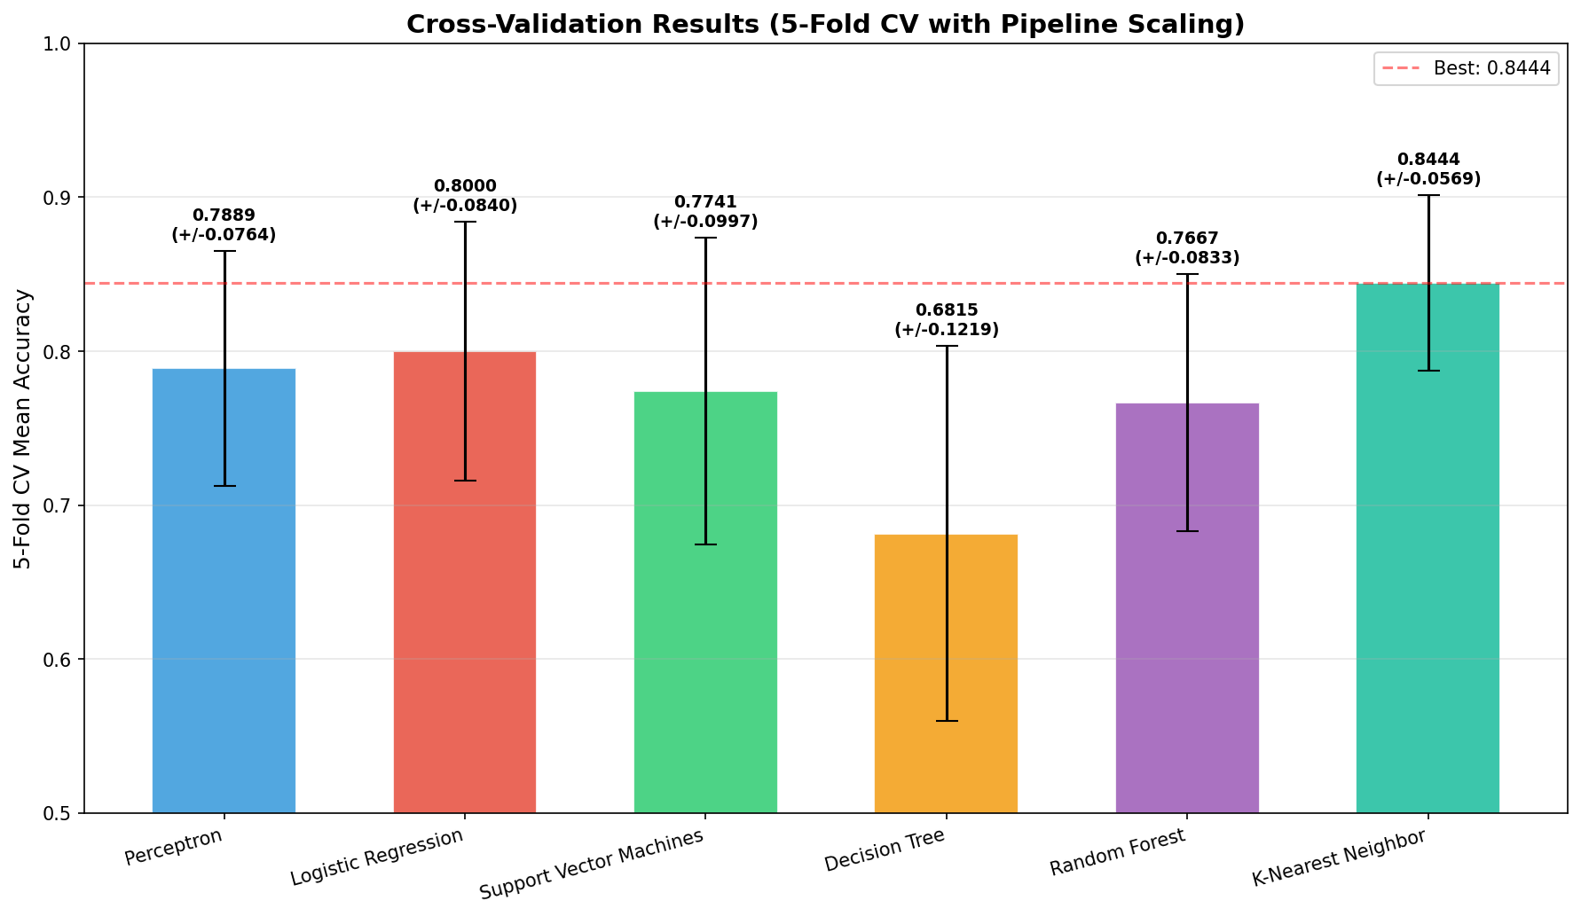
2.8 ROC Curve Analysis
Classifier | AUC Score
Support Vector Machines | 0.9784
Logistic Regression | 0.9683
Random Forest | 0.9668
K-Nearest Neighbor | 0.9654
Decision Tree | 0.7727
Perceptron | N/A (no probability support)
SVM achieved the highest AUC of 0.9784, meaning it has the best ability to discriminate between patients with and without heart disease across all classification thresholds. Decision Tree had the lowest AUC of 0.7727, consistent with its lower test accuracy of 0.78.
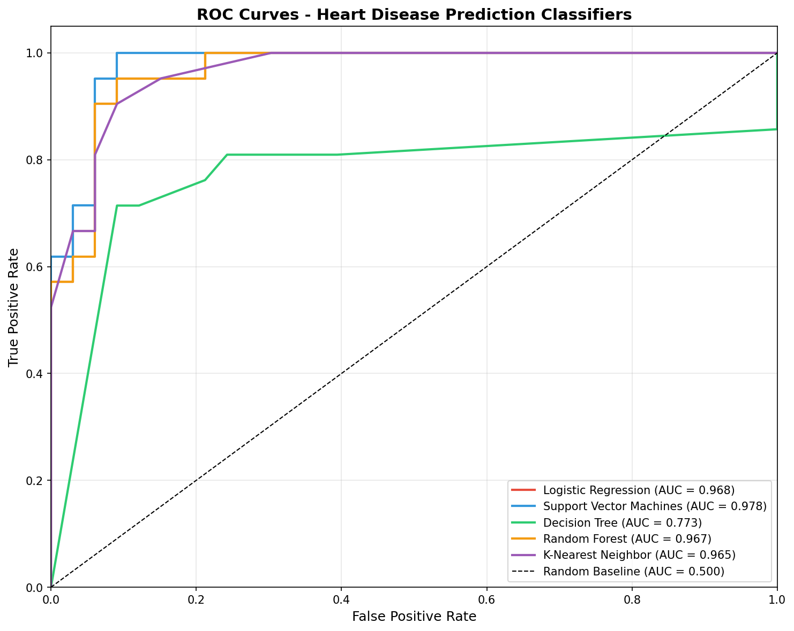
2.9 Learning Curve Analysis (Top 2 Models)
Model | Train Score | CV Score | Gap | Assessment
Support Vector Machines | 0.9231 | 0.7741 | 0.149 | Overfitting
Random Forest | 0.9537 | 0.7667 | 0.187 | Overfitting
Both top models show a training-CV gap greater than 0.10, indicating moderate overfitting. This suggests that additional training data could improve generalization performance. The gap is more pronounced for Random Forest (0.187), indicating it memorizes training patterns more than SVM.
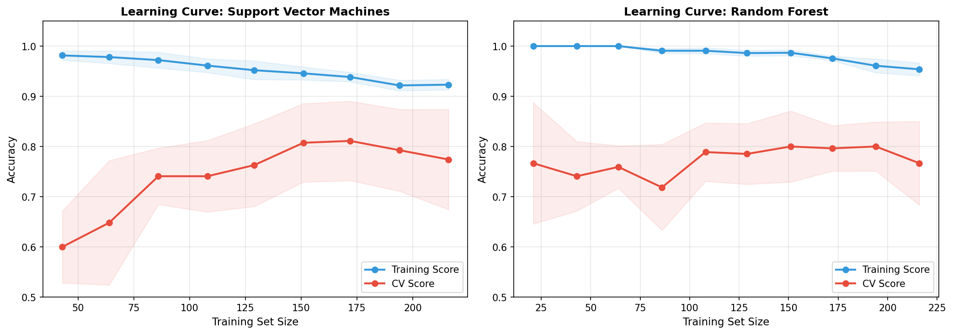
2.10 Extended Performance Comparison
Method | Test Acc | Comb Acc | CV Mean | CV Std | AUC
Perceptron | 0.85 | 0.84 | 0.7889 | 0.0764 | N/A
Logistic Regression | 0.91 | 0.86 | 0.8000 | 0.0840 | 0.9683
Support Vector Machines | 0.94 | 0.92 | 0.7741 | 0.0997 | 0.9784
Decision Tree | 0.78 | 0.90 | 0.6815 | 0.1219 | 0.7727
Random Forest | 0.93 | 0.94 | 0.7667 | 0.0833 | 0.9668
K-Nearest Neighbor | 0.91 | 0.84 | 0.8444 | 0.0569 | 0.9654
2.11 Management Summary – Problem 2
After testing six different machine learning methods on the heart disease dataset, the Support Vector Machine performed the best with a test accuracy of 0.94 and a combined accuracy of 0.92. Random Forest came in second at 0.93 test accuracy. Decision Tree had the lowest accuracy at 0.78, which I think is because it struggles more with the complex relationships in this data compared to ensemble methods. I also ran 5-fold cross-validation to get a more reliable accuracy estimate. Interestingly, KNN with K=11 had the best cross-validation score of 0.844 with a low standard deviation of 0.057, meaning it performed the most consistently across different splits of the data. I found K=11 by testing all values from 1 to 30 and picking the one with the highest CV score. The ROC analysis showed SVM had the highest AUC of 0.978, which means it does the best job of separating disease from non-disease patients. Both SVM and Random Forest showed some overfitting based on the learning curves, with gaps of 0.149 and 0.187 between training and CV scores, so more training data would probably help. Overall I would recommend SVM for AMAPE's prediction system based on its highest test accuracy and AUC, but KNN is also a strong option if consistency across different patient groups is more important.

